Ansible Task -03
- Write a single ansible playbook which will install apache and nginx. Note: Playbook should not be hardcoded and pass the variables from different file.
- Ansible playbook to create 10 different directories with minimal code and directory names should be passed as variables.
- Ansible playbook to copy ssh-keygen from master to worker nodes. Note: a)Provision new 3 ec2 machines, one master and two worker nodes. b)Create common user called ansadm and provide sudo priviliges on 3 ec2 instances. c)Create ssh-keygen in master and your playbook should copy the keygen making it password less authentication.
- Ansible playbook to inject ansible vault variables.
Task 1: Install Apache and Nginx using variables
Objective: Install Apache and Nginx using a single playbook. Package names and service names must be defined in a separate variables file.
Step 1: Create the project directory
Run these commands on the Master node:
cd ~/ansible-lab
mkdir -p task1
cd task1
Step 2: Create the variables file
nano vars.yml
Add the following content:
---
web_packages:
- apache2
- nginx

web_services:
- apache2
- nginx
Save the file using Ctrl+O, press Enter, and exit with Ctrl+X.
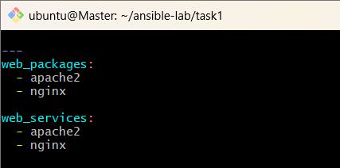
Step 3: Create the Ansible playbook
nano install-webservers.yml
Add the following content:

---
- name: Install Apache and Nginx
hosts: workers
become: true
vars_files:
- vars.yml

tasks:
- name: Install web server packages
ansible.builtin.apt:
name: "{{ web_packages }}"
state: present
update_cache: true

- name: Start and enable web services
ansible.builtin.service:
name: "{{ item }}"
state: started
enabled: true
loop: "{{ web_services }}"
How it works:
- vars_files loads variables from vars.yml.
- web_packages defines the packages to install.
- web_services defines the services to start.
- loop processes both services without duplicating tasks.
- become: true requests elevated privileges.
Note: Both web servers normally use port 80 by default, so they may conflict when starting. If that happens, configure separate ports before expecting both services to run simultaneously.
Step 4: Check the inventory
cd ~/ansible-lab
cat inventory
Ensure the inventory contains your worker nodes:
[workers]
worker1 ansible_host=172.31.5.189
worker2 ansible_host=172.31.11.14

[workers:vars]
ansible_user=ansadm
ansible_python_interpreter=/usr/bin/python3
Keep your existing inventory if it already contains the correct configuration.
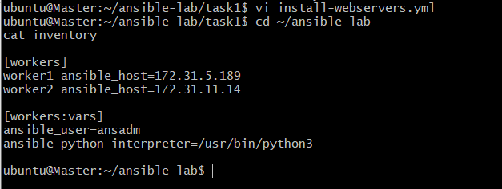
Step 5: Validate the playbook
cd ~/ansible-lab/task1
ansible-playbook -i ../inventory install-webservers.yml --syntax-check
Expected output:
playbook: install-webservers.yml

Step 6: Execute the playbook
ansible-playbook -i ../inventory install-webservers.yml
If you receive a privilege-escalation or sudo error, stop and troubleshoot it before proceeding.
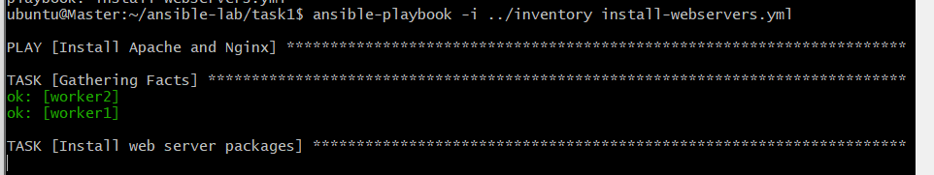
Step 7: Verify installation
ansible workers -i ../inventory -b -m shell \
-a "dpkg -l apache2 nginx | grep '^ii'"
Verify service status:
ansible workers -i ../inventory -b -m shell \
-a "systemctl is-active apache2 nginx"
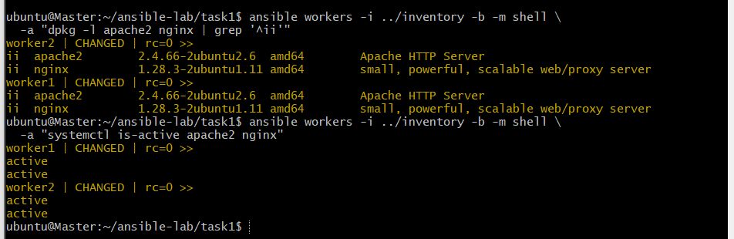

Task 2: Create 10 directories using variables
Objective: Create ten directories with minimal playbook code. Directory names must come from a separate variables file.
Step 1: Create the directory
cd ~/ansible-lab
mkdir -p task2
cd task2
Step 2: Create the variables file
nano dirs.yml
Add:

---
directory_names:
- dev
- test
- prod
- logs
- backup
- scripts
- config
- reports
- data
- archive
Step 3: Create the playbook
nano create-directories.yml
Add:

---
- name: Create ten directories
hosts: workers
become: true
vars_files:
- dirs.yml

tasks:
- name: Create directories
ansible.builtin.file:
path: "/opt/{{ item }}"
state: directory
mode: "0755"
loop: "{{ directory_names }}"
This playbook uses one task and a loop to create all ten directories under /opt.
Step 4: Validate the playbook
ansible-playbook -i ../inventory create-directories.yml --syntax-check
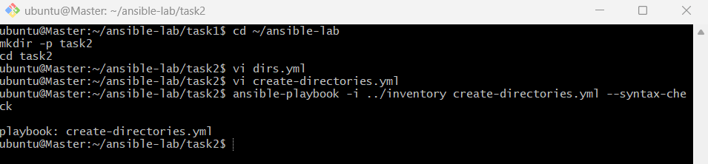
Step 5: Execute the playbook
ansible-playbook -i ../inventory create-directories.yml
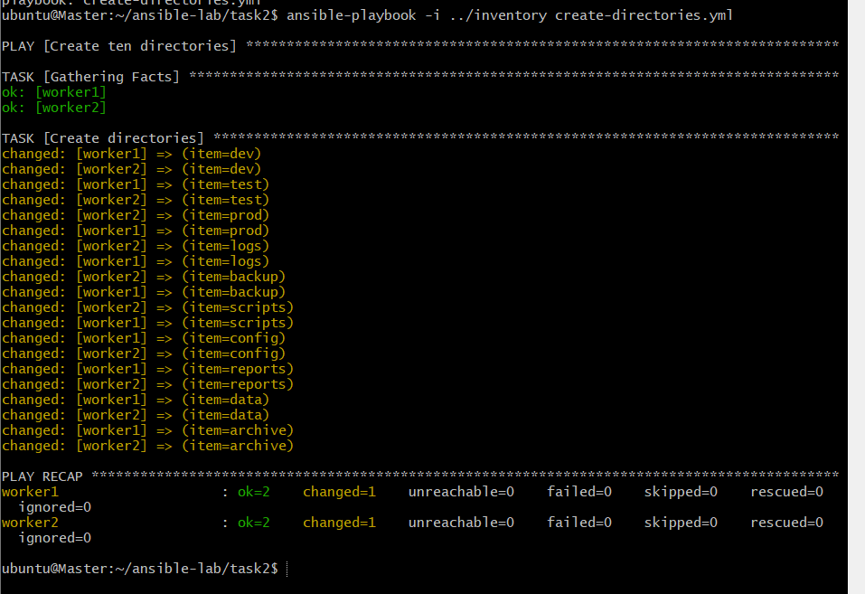
Step 6: Verify the directories
ansible workers -i ../inventory -b -m shell \
-a "ls -ld /opt/dev /opt/test /opt/prod /opt/logs /opt/backup /opt/scripts /opt/config /opt/reports /opt/data /opt/archive"
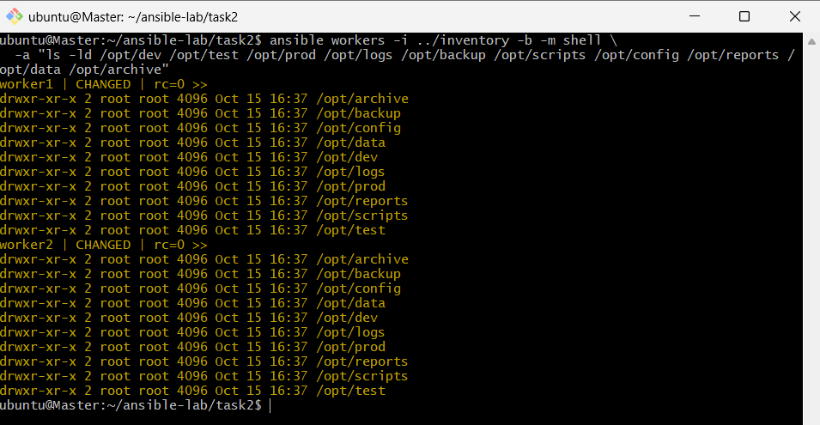

Task 3: Configure passwordless SSH from Master to Worker nodes
Objective: Provision three EC2 instances, create the common ansadm user with sudo privileges, generate an SSH key on the Master, and configure passwordless authentication to both workers.
Your three EC2 instances and ansadm user already exist, so you can reuse them instead of creating duplicate instances.
Part A: Verify the EC2 instances and users
Step 1: Verify connectivity
On the Master:
cd ~/ansible-lab
ansible all -i inventory -m ping
Expected: Each configured host returns SUCCESS and pong.
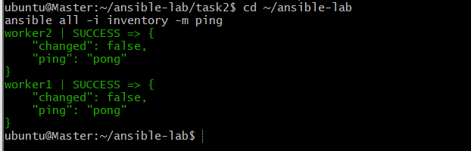
Step 2: Verify the ansadm user
whoami
id
The current user should be ansadm.
Check the workers:
ansible workers -i inventory -m command -a "id"
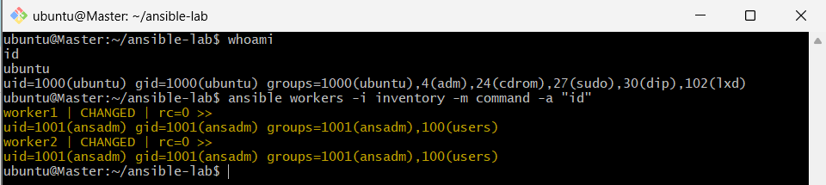
Step 3: Verify sudo access
ansible workers -i inventory -m command -a "sudo -n id"
Expected output includes:
uid=0(root)
If this fails, resolve the sudo configuration before running playbooks that use become: true.
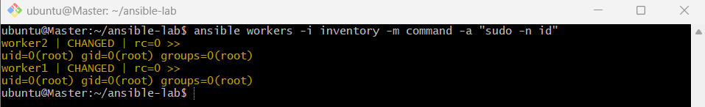
Part B: Generate an SSH key on the Master
Step 4: Check for an existing key
ls -l ~/.ssh/
If id_ed25519 and id_ed25519.pub already exist, you can reuse them.
Otherwise, generate a key:
ssh-keygen -t ed25519 -f ~/.ssh/id_ed25519
For a lab setup, you can leave the passphrase empty if unattended SSH access is required.
Step 5: Verify the public key
cat ~/.ssh/id_ed25519.pub
Security rule: Copy only the public key (id_ed25519.pub). Never copy the private key (id_ed25519) to the worker nodes.
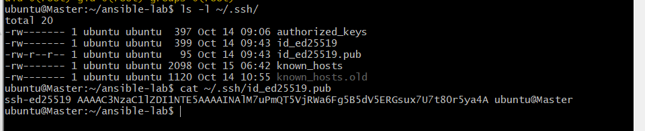
AAAAC3NzaC1lZDI1NTE5AAAAINAlM7uPmQT5VjRWa6Fg5B5dV5ERGsux7U7t80r5ya4A
Part C: Create the key-distribution playbook
Step 6: Create the playbook
cd ~/ansible-lab
mkdir -p task3
cd task3
nano copy-ssh-key.yml
Add:

---
- name: Configure passwordless SSH from Master
hosts: workers
gather_facts: false

tasks:
- name: Add Master's public key to worker nodes
ansible.posix.authorized_key:
user: ansadm
state: present
key: "{{ lookup('file', '~/.ssh/id_ed25519.pub') }}"
This task adds the Master's public key to the ansadm user's authorized_keys file on each worker.
Step 7: Check the required collection
ansible-galaxy collection list ansible.posix
If the collection is missing:
ansible-galaxy collection install ansible.posix
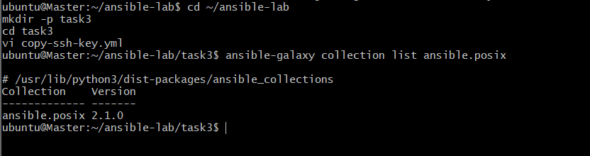
Step 8: Validate and execute
ansible-playbook -i ../inventory copy-ssh-key.yml --syntax-check
Then:
ansible-playbook -i ../inventory copy-ssh-key.yml
The workers must already be reachable through SSH, and the remote ansadm account must have permission to update its SSH configuration.
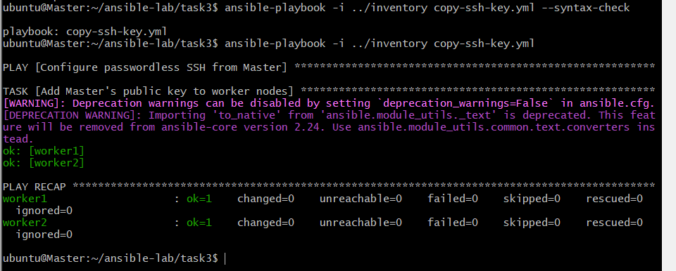
Step 9: Verify passwordless authentication
ssh -o BatchMode=yes ansadm@172.31.5.189 "hostname"
ssh -o BatchMode=yes ansadm@172.31.11.14 "hostname"
Expected: Both commands print the corresponding worker hostname without prompting for a password.
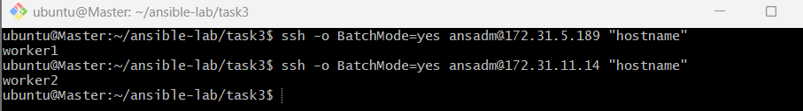

Task 4: Inject Ansible Vault variables
Objective: Store sensitive values in an encrypted file and load them into an Ansible playbook using vars_files.
Step 1: Create the project directory
cd ~/ansible-lab
mkdir -p task4
cd task4
Step 2: Create an encrypted variables file
ansible-vault create vault.yml
Enter a strong Vault password when prompted.
In the editor, add:

---
app_username: "demo_user"
app_password: "ReplaceWithYourOwnSecret"
environment_name: "dev"
Save and exit the editor.
Ansible Vault encrypts the file, protecting the variables at rest.
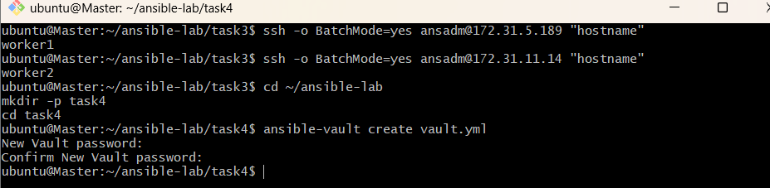
Step 3: Verify encryption
head -n 1 vault.yml
Expected: The first line begins with:
$ANSIBLE_VAULT;

Step 4: Create the playbook
nano vault-demo.yml
Add:

---
- name: Load Ansible Vault variables
hosts: workers
gather_facts: false
vars_files:
- vault.yml

tasks:
- name: Display environment
ansible.builtin.debug:
msg: "Environment: {{ environment_name }}"

- name: Verify that Vault variables are loaded
ansible.builtin.assert:
that:
- app_username | length > 0
- app_password | length > 0
success_msg: "Vault variables loaded successfully"
The playbook loads the encrypted variables and verifies that the username and password are available without printing the password.
Step 5: Validate the playbook
ansible-playbook -i ../inventory vault-demo.yml --syntax-check --ask-vault-pass
Step 6: Run the playbook
ansible-playbook -i ../inventory vault-demo.yml --ask-vault-pass
Enter your Vault password when prompted.
Expected output includes:
Environment: dev
Vault variables loaded successfully
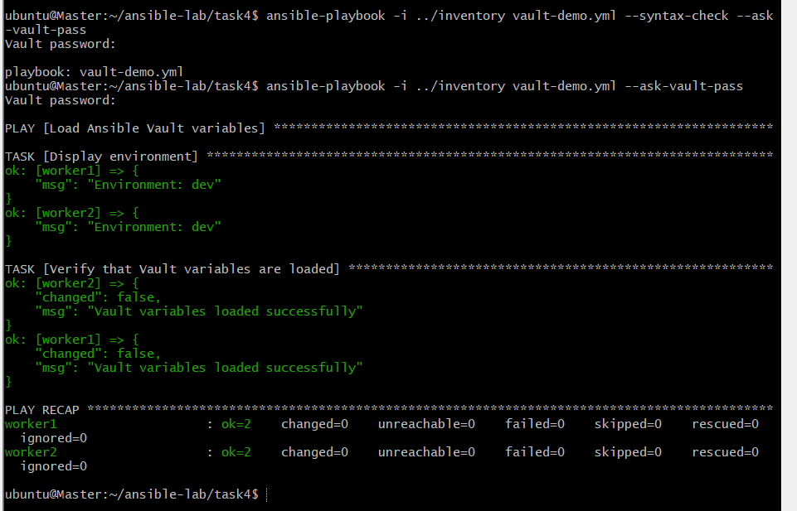
Step 7: Edit or change the Vault password
To edit encrypted variables:
ansible-vault edit vault.yml
To change the Vault password:
ansible-vault rekey vault.yml
Never commit Vault passwords or unencrypted secrets to a public GitHub repository.
